**Lab progrma1**: led on and off every one sec and after 2 sec

**Code:**

int led=8;

void setup()

{

pinMode(led, OUTPUT);

Serial.begin(9600);

}

void loop()

{

digitalWrite(led, HIGH);

delay(1000); // Wait for 1000 millisecond(s)

Serial.println("led on");

digitalWrite(led, LOW);

delay(1000); // Wait for 1000 millisecond(s)

Serial.println("led off");

}

**Output:**

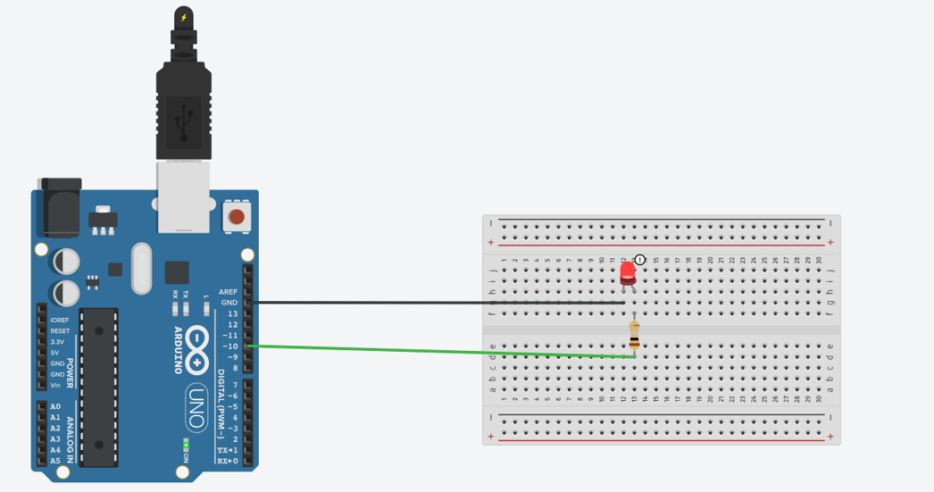

**Lab program 2**: Buzz sound on and off

**Code**: int buzz=8;

void setup()

{

pinMode(buzz,OUTPUT);

Serial.begin(9600);

}

void loop()

{

digitalWrite(buzz,HIGH);

delay(1000); // Wait for 1000 millisecond(s)

Serial.println("Buzz on");

digitalWrite(buzz, LOW);

delay(1000); // Wait for 1000 millisecond(s)

Serial.println("Buzz off");

}

**Output:**

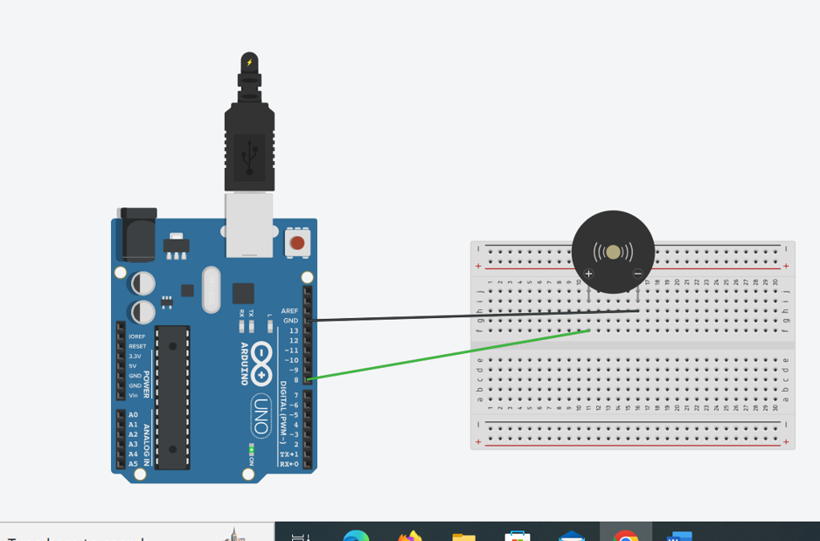

**Lab program:** push botton,lead

**Code:** int led=8;

int pbutton=12;

void setup()

{

pinMode(led, OUTPUT);

pinMode(pbutton,OUTPUT);

}

void loop()

{

int val;

val=digitalRead(pbutton);

Serial.println(val);

if(val==1){

digitalWrite(led, HIGH);

delay(1000); // Wait for 1000 millisecond(s)

}

else{

digitalWrite(led, LOW);

delay(1000); // Wait for 1000 millisecond(s)

}

}

Output: 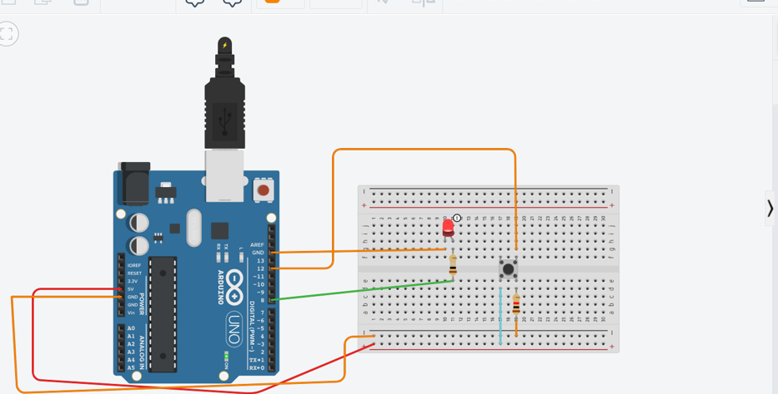

**Lab program 4:** using buzzer and sensor

Code:

int spin=13;

int bpin=8;

int state=LOW;

int val=0;

void setup()

{

pinMode(spin, INPUT);

pinMode(bpin, OUTPUT);

Serial.begin(9600);

}

void loop()

{

val=digitalRead(spin);

if(val==HIGH)

{

digitalWrite(bpin, HIGH);

if(state==LOW){

Serial.println("moton detected");

}

}

else{

digitalWrite(bpin, LOW);

if(state==HIGH){

Serial.println("moton ended");

}

}

}

**Code:**

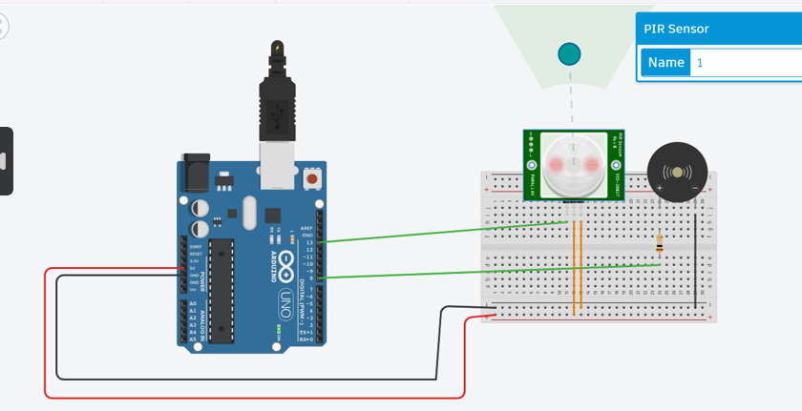

**Program 6:** potenometer and led.

**Code:**

int ledpin=8;

int pmpin=A1;

void setup()

{

pinMode(ledpin, OUTPUT);

pinMode(pmpin, INPUT);

}

void loop()

{

int pminp=analogRead(pmpin);

int val=pminp/4;

analogWrite(val,pmpin);

}

**Output:**

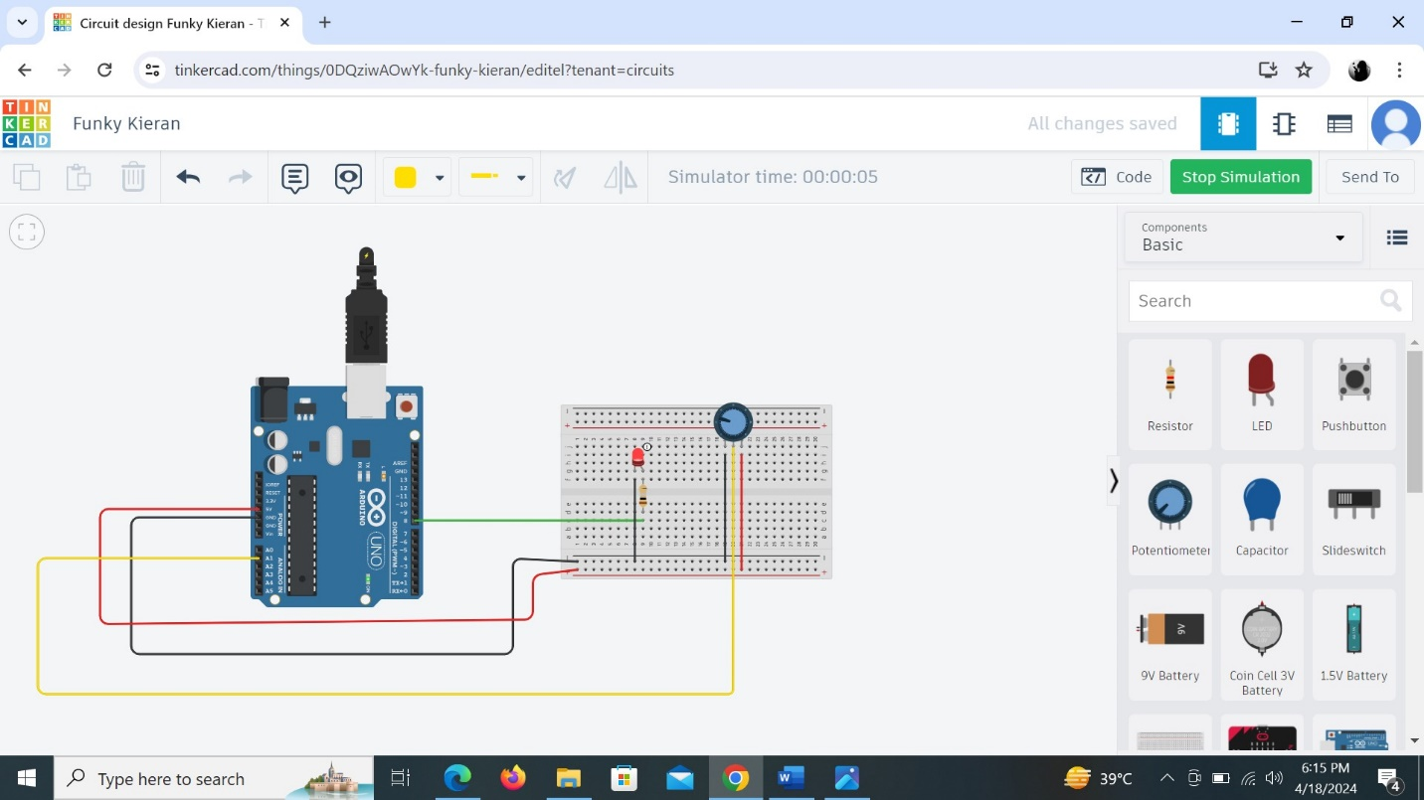

**Lab program:** ldr and led

**Code:**

int led=8;

int ldr=A1;

void setup()

{

pinMode(led, OUTPUT);

pinMode(ldr, INPUT);

Serial.begin(9600);

}

void loop()

{

int i=analogRead(ldr);

Serial.println(i);

if(i>350){

digitalWrite(led,1);

}

else{

digitalWrite(led,0);

}

}

**Output:**

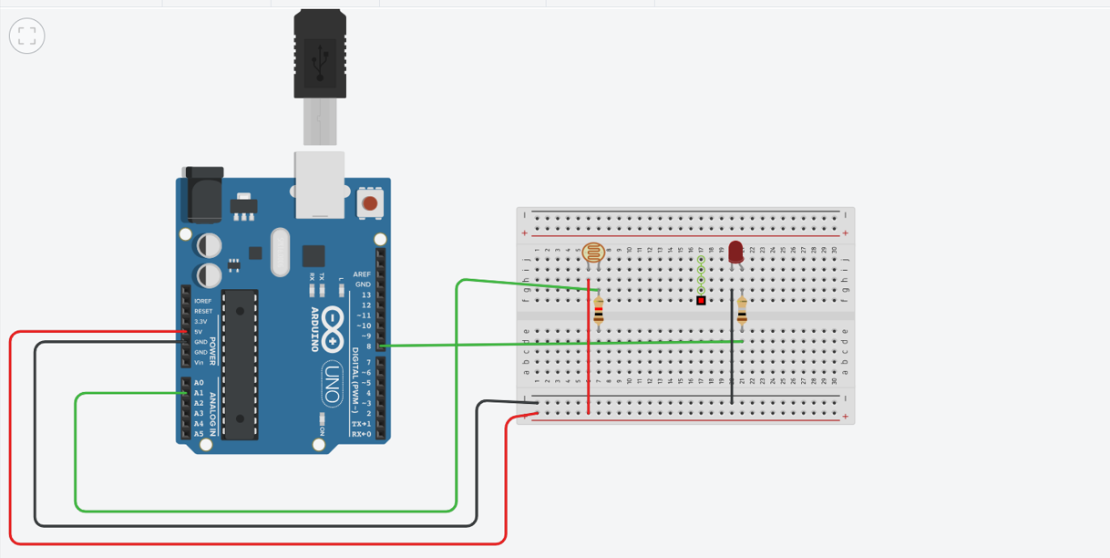

**Labprogarm:** ultarno sensor and led, motor

**Code:**

int trig=13;

int echo=12;

int led=8;

int motor=7;

float du;

float d;

void setup()

{

pinMode(trig, OUTPUT);

pinMode(echo, INPUT);

pinMode(led, OUTPUT);

pinMode(motor, OUTPUT);

void loop()

{

digitalWrite(trig, LOW);

delayMicroseconds(10);

digitalWrite(trig, HIGH);

delayMicroseconds(10);

digitalWrite(trig,LOW);

du=pulseIn(echo,HIGH);

d=(du*0.034)/2;

Serial.println("distance in cm");

Serial.println(d);

delay(500);

if(d>=50)

{

digitalWrite(led,1);

digitalWrite(motor,1);

}

else{

digitalWrite(led,0);

digitalWrite(motor,0);

}

}

**Output**:

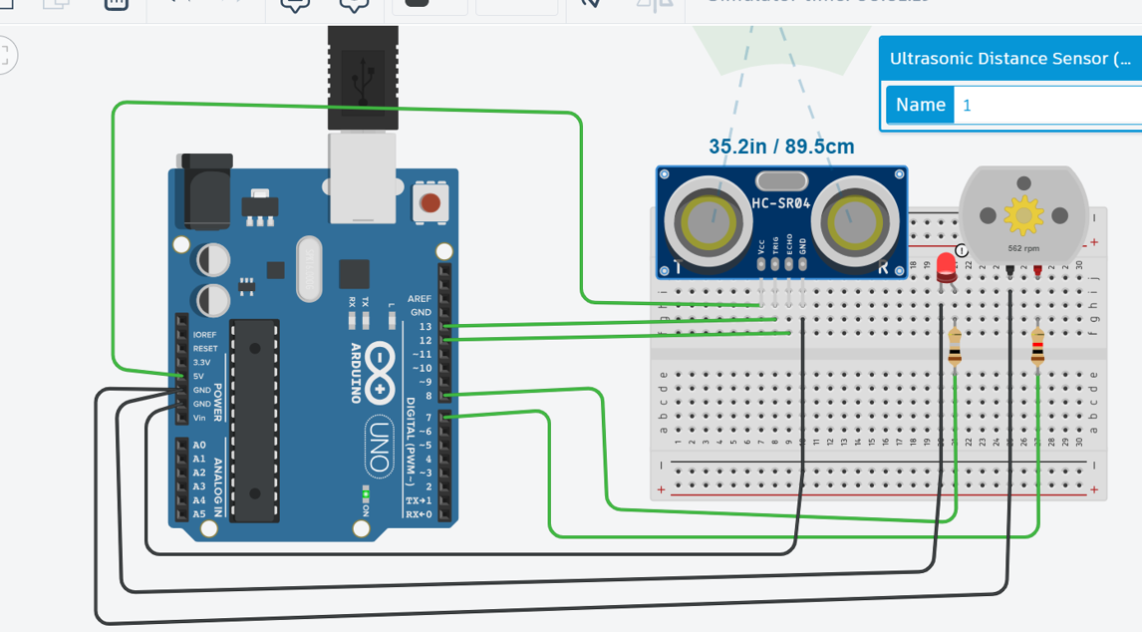

**Program 9:** RgB led and resistor

**Code:**

int red_light_pin=11;

int green_light_pin=10;

int blue_light_pin=9;

void setup()

{

pinMode(red_light_pin, OUTPUT);

pinMode(green_light_pin, OUTPUT);

pinMode(blue_light_pin, OUTPUT);

Serial.begin(9600);

}

void loop()

{

RGB_color(255,0,0);

RGB_color(0,255,0);

RGB_color(0,0,255);

RGB_color(255,255,25);

RGB_color(0,255,255);

RGB_color(255,0,255);

RGB_color(255,255,0);

RGB_color(255,255,255);

}

void RGB_color(int red_light_value,int green_light_value,int blue_light_value)

{

digitalWrite(red_light_pin,red_light_value);

digitalWrite(green_light_pin,green_light_value);

digitalWrite(blue_light_pin,blue_light_value);

}

**Output:**

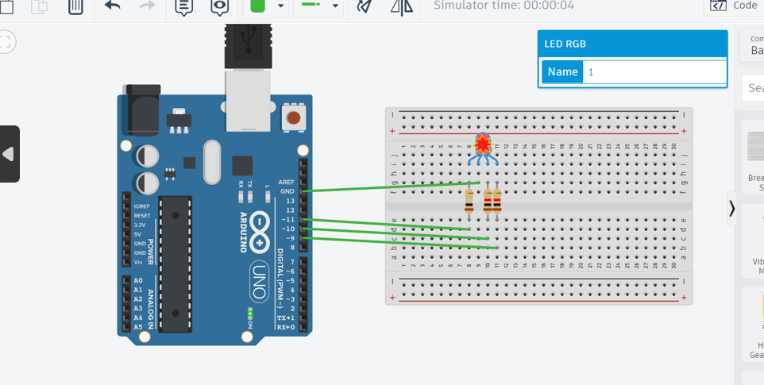

Lapprogram :9 4*4 keypad

**Code:** #include<Keypad.h>

const byte ROWS = 4;

const byte COLS = 4;

char keys[ROWS][COLS] = {

{'1','2','3','A'},

{'4','5','6','B'},

{'7','8','9','C'},

{'*','0','#','D'}

};

byte rowPins[ROWS] = {9, 8, 7, 6};

byte colPins[COLS] = {5, 4, 3, 2};

Keypad keypad = Keypad(makeKeymap(keys), rowPins, colPins, ROWS, COLS );

void setup(){

Serial.begin(9600);

}

void loop(){

char key = keypad.getKey();// Read the key

if (key){

Serial.print("Key Pressed :");

Serial.println(key);

}

}

**Output:**

